

**User Manual**

EE30007

Content

**1** **Notice** 2

**2** **Specification** 2

**3** **Main parameter** 3

**4** **Display** 3

**5** **Indicator** 4

**6** **Charging** 4

**7** **Operation** 5

**8** **Totalizer** 6

**9** **Charge** 6

**10** **PLU function** 7

**11** **Parameter setting** 8

**12** **Error message** 9

1. **Notice**
   1. Please charge before first use.

When low power sign shows, please use the original adapter to charge. Charge light is red, it means scale is in charging mode. When charge light turn to green, it means charging finished. The charging length is about 8-10 hours.

* 1. Put and balance the electrical scale on the stable and flat table with four adjustable feet. Please notice the air bubble should be kept in the center of circle.
  2. Please avoid the water.
  3. When the value of the scale is not zero, press “Zero”, zero will come.
  4. If mobile or wireless machines are in use nearby when turning on the scale, the display will flash once, and then become normal. If it doesn't work, please turn on again.
  5. The original adaptor should be used when charging.
  6. After a long-time use (more than one year), the rechargeable battery can't keep using for long after more than 12-hour charging, which means new one should be replaced. If you have no idea how to replace, please ask a nearby agency to give you a helping hand.
  7. Please turn off the scale when it won't be used for a long time.
  8. Avoid putting the weight on the scale when turning it on.

1. **Specification**
   1. Big size LCD/LED display, easy to read.
   2. More backlight setting to fit the requirements.(LCD)
   3. More brightness setting to fit the requirements.(LED)
   4. Solid frame design to insure the stable weighing.
   5. With data memory, can store many weighting date.
   6. Fast reading, stable, accurate, easy using.
   7. Low power alarm, charging light show.
2. **Main parameter**
   1. Division: 1/6000
   2. Power:50mA(LCD)/150mA(LED)
   3. Display: LCD/LED display
   4. Load cell range: 3mV/V
   5. Adaptor:DC6V/4AH(when battery voltage less than5.6V,it will show the sign of low power)
   6. Temperature&Humidity:0-40℃, lessthan90%RH
   7. Storage: -25~55℃
3. **Display**

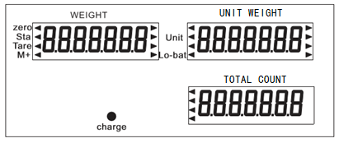

* 1. Weight-----The weight of goods.
  2. Unit weight------The unit weight of goods.
  3. Total Count-----The total count of goods.
  4. Units to choose, indication of [◄].
  5. Zero----Weight value is 0.
  6. Tare-----Used as tare key in pricing mode
  7. Stable----Weight value is stable.
  8. Lo-bat---When battery power lower than 5.6V, it will show.

1. **Indicator**
   1. The connection

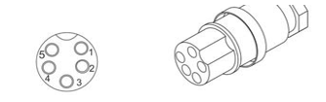

|  |  |  |
| --- | --- | --- |
| PIN | definition | note |
| 1 | E+ |  |
| 2 | E- |  |
| 3 | S+ |  |
| 4 | S- |  |
| 5 | Ground | Connect to the shield wire |

* 1. How to fix

Put the cable through the pillar, then insert the pillar into base, fasten the fixed screw. After put the cable through the holder. Insert the holder into the bracket of the indicator. Fix the load cell connector. Adjust the holder for right position, and then fasten the plastic screw on the display.

1. **Charging**

When charging, the light is red. It will turn green when charging finished (the charging length should be 8-10h).

Attention: do not use up the battery, otherwise the battery will be broken. If you do not use it for a long time, you should recharge in 40 days.

After charge, please take off the power supply, do not always connect to power supply.

1. **Operation**

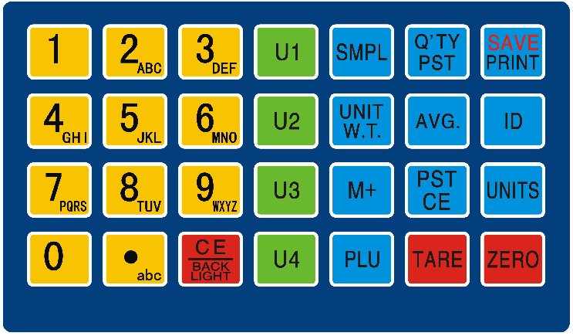

* 1. [0-9] The digital key, input the unit price. In letter input mode can input letters.
  2. [**.**abc ] The decimal point key. When input item SKU number, the key can switch input number or letter.
  3. [Unit] Select the pricing computing units.
  4. [Zero] Let the weight display's value back to zero.
  5. [Tare] Put on the tare weight, the press this key to deduct the tare weight.
  6. [CE] When input wrong unit price, press this key can clean the wrong numbers. If the interval time of input numbers more than 5s, the scale will clean the number which input before 5s, and read the number which input after 5s as new input one.
  7. [个数设定]根据输入的数量进行采样
  8. [单重设定]把输入的数值当作单重
  9. [累计]累计单重和总数,在重量为0时,为重示功能,即显示已经累计的价格.
  10. [累计清除]清除已经累计的数量.
  11. [数量预设]设置上下限报警
  12. [自动平均]开关自动平均功能.打开时屏幕有箭头指向”自动平均”
  13. [部品号]用于直接输入部品号.
  14. [PLU] use to get the stored PLU value. E.g. input number 12,then press [PLU], the No.12 stored PLU values will show.(Include unit weight, SKU id,…)

也可以长按[PLU],进入PLU设置.

* 1. [U1]-[U4] Get the stored PLU value directly.
  2. [Print] In weighing mode and recheck mode, press this key can print out the content.

1. **Totalizer**
   1. Weight value is known

Put on the weights, input the unit price, total price window will show the counted price, press [M+], total price will been stored.

At this time, the display will show the accumulative total price, then back to the weighing mode.

* 1. Price value is known

Input the price, press [M+], and the price will accumulate and been stored.

At this time, the display will show the accumulative total price, then back to the weighing mode.

* 1. Show the stored price

In weighing mode, press [MR]. The weight window shows “Total”. The unit price window shows the time number of accumulate. The total price window shows the total price of accumulate.

To check the price of very count time, press [MR]. The weight window shows “ADD XX”, XX means the accumulate number of time. The unit price window shows the unit price of this accumulate number of time. The total price window shows the total price of this accumulate number of time.

Back to weighing mode, press [C].

* 1. Clean the stored value

In weighing mode, press [MR] to clean all accumulative value.

To clean the single accumulative value, please press [MR] after show the single accumulative total value in step 8.3.

1. **Charge**
   1. By single weighing item

Put on the single weights, input the unit price. The total price window shows the counted price. Press [CH], the weight window shows [CHARGE]. At this time, input the number of received money, then press [CH] or wait for 2s, the unit price window will show the return change.

* 1. By accumulative total

In step 6.3, after show the accumulative total price, press [CH]. The weight window shows [CHARGE], at this time, use number keypad to input the received money, then press [CH] or wait for 2s, the unit price window will show the return change.

1. **PLU function**
   1. In pricing computing mode, use number keypad to input PLU serial number, then press [PLU],can get the weights name and unit price of the corresponding weights. The display will show the item name once and back to pricing computing mode.
   2. In pricing computing mode, use number keypad to input PLU serial number, then press [PLU],can get the weights name and unit price of the corresponding weights. The display will show the item name once and back to pricing computing mode.

Agent can set if print out the current weight value and unit price.

* 1. Edit the PLU data

In pricing computing mode, press and hold [PLU] key for 3s to enter PLU date edit mode.

* + 1. The weight window shows “set”, user input the PLU serial number, then press [PLU] (or press “Ux” key directly), the weight window will show the inputted PLU serial number. Now, scale enter into unit price edit mode.
    2. If this PLU serial number already stored, the weight window will show the stored unit price. If it is a new one, the weight window will show the unit price which get in pricing computing mode. In this two way, user can edit the unit price by use keypad.

Press [PLU] again to store the unit price and enter SKU ID edit. User can use number and letter keypad to input. SKU ID can include letter, please check the step 10.4 to get how to input. After input, press [PLU] to store. Then back to the step 10.3.1 to edit the next SKU ID. If finish, press [C] to exit.

Some models do not have SKU ID edit function. After store the unit price, the scale will back to step 10.3.1.

* 1. Input letter

Press [**.**ABC] once, there will have an arrow sign appear on the display point to “ABC”, or show an “ABC” sign on the display. This means enter to letter input mode.

Now, user can input letter by use number keypad. E.g. press [1abc] once, the display will show “A” and blink, press once again, the display will show “B”, and so on. After the letter stops blink, it means this letter has been inputted. Back to number input mode, press [.ABC], the letter input sign will disappear also.

**\*\* This PLU function can use software to edit by PC. Use software can edit goods name and expiration date. Want to know more, please contact the local agent.**

1. **Parameter setting**
   1. In weighing mode, press and hold on [unit], then press [C], to enter the parameter setting.
   2. In the parameter setting mode, press [unit] to enter the next parameter, press [MC] to modify the value of the parameter.
   3. Parameters

|  |  |
| --- | --- |
| Parameters | Function |
| Unitn XXX | N means the serial number of the units. XXX means the effective unit or choose OFF to shut down this unit site. Press [unit] to modify the next unit. This model can choose 7pcs units. |
| F1 BL(LCD) | Back light setting for LCD model, can choose (OFF), (ON) or (AUTO). |
| F1 LtN(LED) | Brightness setting for LED model, can choose 3 brightness level. |
| F1C SL | Sleep time, to close the backlight after weight value is stable. |
| F2 PER | To choose the Precision of the total price. E.g.0.01 means price can show to 0.01. 0.5 means price can show to 0.5. |
| F3 LAP | To choose if print out when load PLU value. |
| F4 CST | To choose if function keys (E.g. [ZERO], [CH], [M+],..] effective after weight value stable. |
| F5 MAE | To choose if need move away weights and wait the stable sign appear every time when user continuous accumulate. |
| F6 FIL | Filter intension parameter, the greater the X value, the greater the intensity, the date more stability. |
| F7 TFC | 232 send mode(Option) |
| F8 TPF | Print mode(Option) |
| F9 TBU | 232baud rate(Option) |

1. **Error message**

|  |  |  |
| --- | --- | --- |
| Message | Problem | Solve way |
| ADO--- | Over A/D resolution range | Remove the weights of the pan or send back to the agent. |
| ADL--- | Over A/D resolution range | Remove the weights of the pan or send back to the agent. |
| OVR--- | Over load (max: capacity +9e) | Check the weight of the weights, cannot exceed Max Cap.+9e |
| Battery symbol flash | Low power alarm | Charge battery |
| Lo-Bat | Low power alarm | Charge battery |