

**Multi-Function Smart Indicator User Manual**

EE40014

**Content**

**1** **Notice** 2

**2** **Specification** 2

**3** **Main parameter** 3

**4** **How to fix** 3

**5** **Port** 4

**6** **On/Off** 4

**7** **Charging** 4

**8** **Display** 5

**9** **Screen keypad** 6

**10** **Keypad** 6

**11** **Other interface** 7

**12** **Zero** 11

**13** **Tare** 11

**14** **Choose units** 12

**15** **Counting (Option)** 12

**16** **Select and edit goods** 13

**17** **Input the Hi/Lo limit value directly** 15

**18** **Print** 16

**19** **Check the record** 17

**20** **Export file to U disk** 18

**21** **Parameter setting** 19

**22** **Communication** 20

**23** **Time setting** 25

**24** **User management(Option)** 26

**25** **Units conversion** 28

**26** **Error information** 28

1. **Notice**
   1. Please charging before first use.

When low power sign shows, please use the original adapter to charging. Charging light is red, it means scale is in charging mode. When charging light turn to green, it means charging finished. The charging time is about 5-7 hours.

* 1. Put and balance the electrical scale on the stable and flat table with four adjustable feet. Please notice the air bubble should be kept in the center of circle.
  2. Please avoid the water.
  3. When the value of the scale is not zero, press “Zero”, zero will come.
  4. If mobile or wireless machines are in use nearby when turning on the scale, the display will flash once, and then become normal. If it doesn't work, please power on again.
  5. The original adaptor should be used when charging.
  6. After a long-time use (more than one year), the rechargeable battery can't keep using for long after more than 5-hours charging, which means new one should be replaced. If you have no idea how to replace, please ask a nearby agency to give you a helping hand.
  7. Please turn off the scale when it won't be used for a long time.
  8. Avoid putting the weight on the scale when power it on.

1. **Specification**
   1. 8 inch TFT color display, easy to read.
   2. Adjustable brightness of back light, fit to all time use.
   3. Solid frame design to insure the stable weighing.
   4. With data memory, can store many weighting date.
   5. Fast reading, stable, accurate, easy using.
   6. Low power alarm, charging light show.
   7. Counting, Hi/Lo, target value, select function, …
2. **Main parameter**
   1. Available accuracy: 1/30000
   2. Power adapter: built –in or outer AC 12V/3000mA adapter.
   3. Work current:500mA
   4. Display: 8 inch TFT
   5. Sensor sensitivity range: 1-3mV/V
   6. Power:DC6V/10.0AH(Low power sign appears when voltage lower than 5.6V)
   7. Work temperature: 0-40 ℃, lower than 90%RH
   8. Storage temperature: -25~55℃
3. **How to fix**
   1. Load cell connection

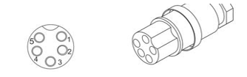

|  |  |  |
| --- | --- | --- |
| Pin | Define | Note |
| 1 | E+ |  |
| 2 | E- |  |
| 3 | S+ |  |
| 4 | S- |  |
| 5 | Ground | Connect to the shielded wire |

* 1. Fix

Put the load cell cable through the pillar, then insert the pillar into base, fasten the fixed screw. After put the cable through the holder. Insert the holder into the bracket of the indicator. Fix the load cell connector. Adjust the holder to right position, and then fasten the plastic screw on the display.

1. **Port**

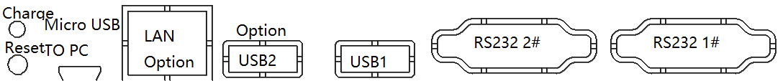

* 1. When indicator crashed, please press down the left button to reset.
  2. When the charging light is red, it means the indicator is charging. When the charging light is green, it means the indicator charging finished.
  3. USB1 can connect to U-disk and scanning gun.
  4. USB2 is option.
  5. RS232 1# can connect to PC, download the print format and so on.
  6. RS232 2# can connect to the outer printer.

1. **On/Off**
   1. Power on

In power off mode, press On/Off key, the display will become bright, after some seconds, the scale system starts completely.

* 1. sleep

In power on mode, press On/Off key, the display will shut down, the scale enters into sleep mode.

* 1. Power off

In power on mode, press and hold On/Off key for 3 seconds, the display

will show shut down dialog box, choose “Power off” to shut down, choose “cancel” to back to normal mode.

1. **Charging**

Connect the indicator with adapter to charging, the charging light is red. It will turn green when charging finished (the charging length should be 5-7h).

Attention: Do not use up the battery, otherwise the battery will be broken. If user do not use the indicator for a long time, user should recharging every 40 days.

After charge, please take off the adapter, please do not always connect the indicator to power supply.

Please do not use other adapters, it may damage the inside battery.

1. **Display**
   1. **Weighing window**

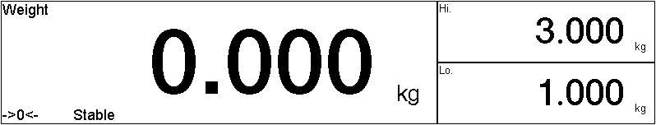

* + 1. The content name of the different area of the window shown on the top left corner of every area. Such as weight, Hi., Lo., unit weight, quantity…
    2. ->0<- ---It means Weight is zero.
    3. Tare---It means here has tare weight.
    4. Stable---When this sign appears, it means the weight value is effective.
    5. Low power---When voltage is lower than 5.5V, this sign will appear to remind user charging the indicator.
  1. The status bar



* + 1.  user login
    2.  Capacity and Division
    3.  Paper out symbol
    4. U disk symbol
    5. WIFI symbol
    6.  Power symbol
    7.  Date and time

1. **Screen keypad**

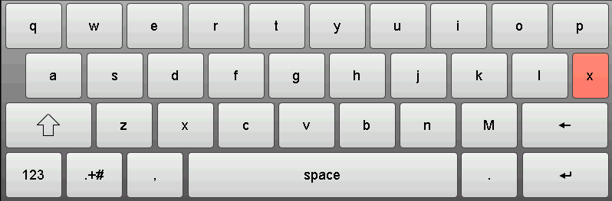

 Close the keypad

 Backspace

 Enter

 Shift, Caps Lock

 Space

 Letter/number keypad switch

 Symbol keypad /number keypad switch

 Back to the default input method.

1. **Keypad**

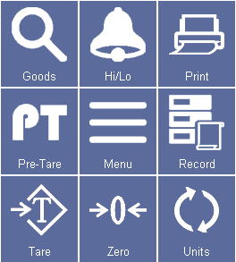

* 1. [Goods] Choose the pre-stored goods.
  2. [Hi/Lo] Enter the Hi/Lo value manually.
  3. [Print] Print and store the recent weight and goods name.
  4. [Menu] Pop-up the setting menu.
  5. [Record] check the stored print recode.
  6. [Units] choose the units.
  7. [Zero] Let the weight value back to zero.
  8. [Pre-Tare] set the tare value.
  9. [Tare] Put on the container, then press [Tare] to reduce the tare weight.

1. **Other interface** 
   1. Hi/Lo limit mode

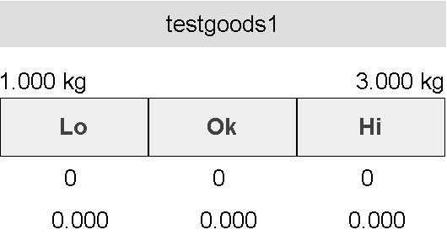

From up and down, the information are goods name, Hi/Lo limit value, the state of Hi/Lo limit, the number of times of Hi/Lo limit, the total weight of Hi/Lo limit.

For an example, when weight is less than the Lo limit, the  will turn to Orange color. At this time, press [Print], the number of times will show under the, and the total weight of Lo limit will show under the number of the times.

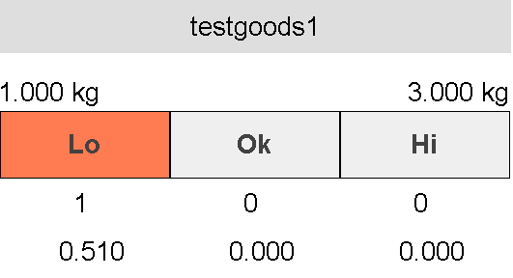

* 1. Target mode

Target mode is similar as Hi/Lo limit mode. The example in counting mode as follow:

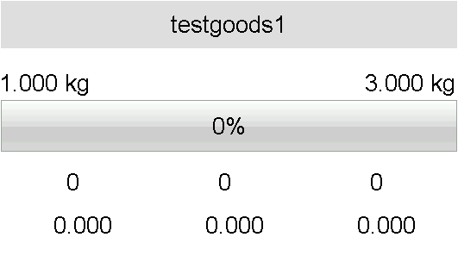

From up and down, the information are goods name, Hi/Lo limit value, the status of Hi/Lo limit, the number of times of Hi/Lo limit, the total weight of Hi/Lo limit.

Target mode set the Lo limit value to target value. For an example, when the weight value is half of the Lo limit, the percent state line will show 50%. At this time, press [Print], the number of times will show under the, and the total weight of Lo limit will show under the number of the times.

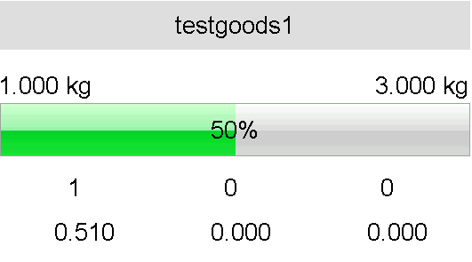

* 1. Sorting mode

Sorting mode use for goods classification.

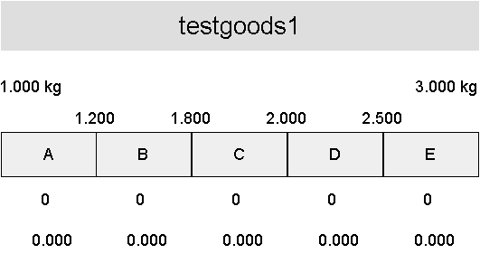

From up and down, the information are goods name, Hi/Lo limit value, the status of Hi/Lo limit, the number of times of Hi/Lo limit, the total weight of Hi/Lo limit.

For an example, when the weight value between 1.2kg-1.8kg, the  will show green color. At this time, press [Print], the number of times will show under the  and the total weight of Lo limit will show under the number of the times.

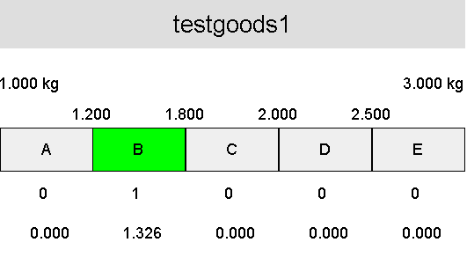

1. **Zero**

When the pan is empty, click  key to let the display weight value back to zero. If the scale is broken or weights heavy than zero range, this key is invalid. If the display has rest weight value when the pan is empty, please use this function. Zero rang= Max. Cap. X4%.

1. **Tare** 
   1. Tare weight is known

Click  key, Tare weight input window will pop-up, please input the tare weight. Then press [confirm], the scale will reduce that tare weight value automatically.

* 1. Tare weight is unknown

Put the container on the pan, click  key, after stable, the weight window will show net weight and tare symbol.

1. **Choose units**

If the units is not the suitable one, click 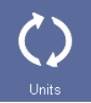 key to choose the right units. The new units will be stored after correct power off.

1. **Counting (Option)**
   1. Unit weight of goods is known

Follow the article 15, set the unit weight in goods edit step.

Choose the unit weight by select goods.

* 1. Common counting function

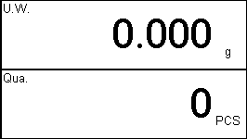

Press the unit weight bar, counting window will pop-up.

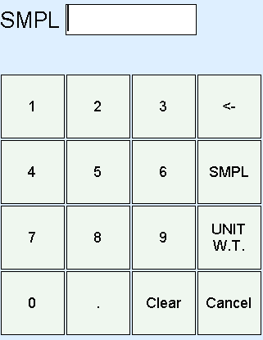

* + 1. Unit weight is known

Input the known weight of weights, press [UNIT W.T], the display will show the counts. At this time, the indicator enter into the counting mode automatically.

* + 1. Unit weight is unknown

Put the sample weights on the pan, use the number keys to input the counts of sample, press [SMPL] key. After the weight value is stable, the quantity window will show the counts of weight.

1. **Select and edit goods**
   1. Select goods

In the main interface, click , the goods select window will pop-up, as follow:

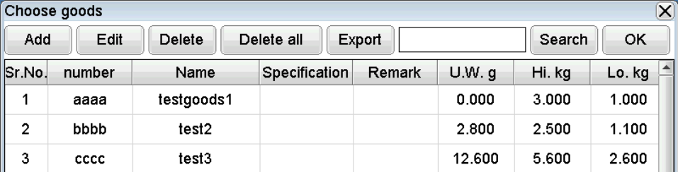

* + 1. Add

Add goods

* + 1. Edit

Select the goods which need to edit, press [Edit] to edit the goods information.

* + 1. Delete

Select the goods which need to delete, press [Delete] to delete the goods. After delete, this recode of goods cannot restored anymore.

* + 1. Delete all

Press [Delete] will delete all the goods information. This function can use to emptying goods information, also can use in data error happened.

* + 1. Export

Insert the U disk, user can export the current data into the U disk. This file can be opened by Excel.

* + 1. Search

Input the key words, such as serial number, goods name, specification, remark, and so on. Then press Search.

* + 1. OK

Select the goods, press [OK], the interface will back to common mode. Then, user can edit the next goods information.

* 1. Add and edit new goods

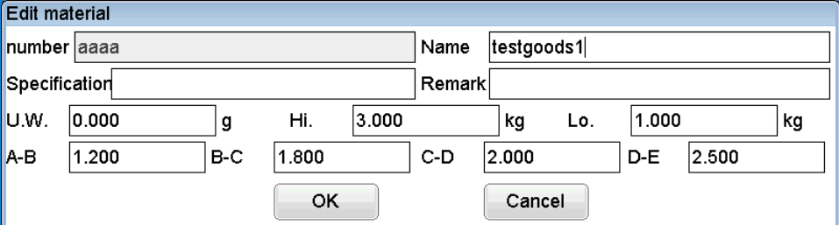

Number: Goods number. After add, this number cannot be edited again.

Name: goods name, user can edit again.

Specification: Specification of goods, user can edit again.

Remark: Remark of goods, user can edit again.

Unit weight: Unit weight of goods, use in counting mode.

Hi limit: In counting mode, the unit is PCS. Otherwise the unit is weight unit, please take attention on the right unit show area.

Low Limit: In counting mode, the unit is PCS. Otherwise the unit is weight unit, please take attention on the right unit show area.

A-B, B-C, C-D, D-E: Use to select mode, use to show the weight/quantity difference of A&B, B&C, C&D, D&E. Please take attention on the right unit show area.

1. **Input the Hi/Lo limit value directly**

Not only call in Hi/Lo limit by select goods, also can use keypad to input Hi/Lo limit.

Click, Hi/Lo limit input window will come out.

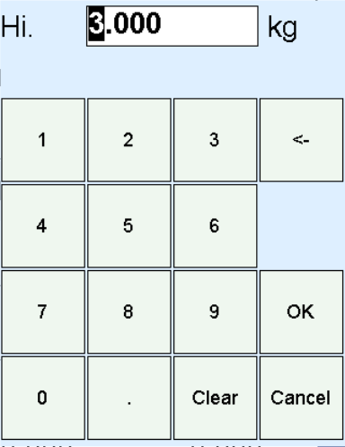

Press number keys to input high limit. Please take attention on the right unit show area. After input, press [OK], the Low limit window will pop-up. Use number keys to input low limit, then press [OK]. Note: The low limit value must lower than high limit value.

1. **Print**

Click can print out the current data and store this data into the indicator.

1. **Check the record**

Click  can check the print record, see follow picture:

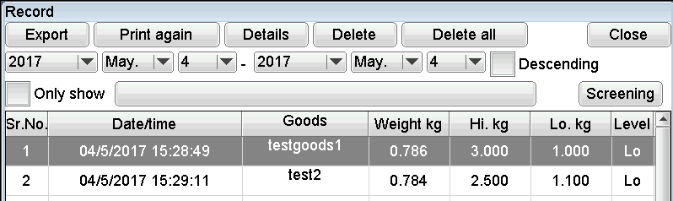

* 1. Export

Insert the U disk, user can export the current data into the U disk. This file can be opened by Excel.

* 1. Re-print

Choose the option which need to be re-print, press [Print again], the indicator will print out the selected item. This function use for printer paper lose or some other situation.

* 1. Details

Choose the option, press [Details], the indicator will show more details of this goods. As follow picture:

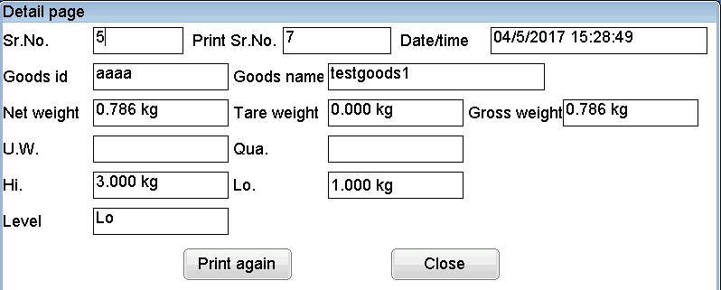

There also have [print again] key in this window.

* 1. Delete

Choose the goods, press [Delete], user can delete the corresponding goods. This goods data cannot be recovered.

* 1. Delete all

Press [Delete all], user can delete all data. This function can use for empty the data, or data error.

* 1. Screening
     1. Choose the date range first
     2. Choose if show data by descending order. If choose this option, the last printed data will show on the top, user can easy to search.
     3. Choose if just show the data of one goods.



Press the key, choose the goods, and then choose this function with tick.



Press [Screening]

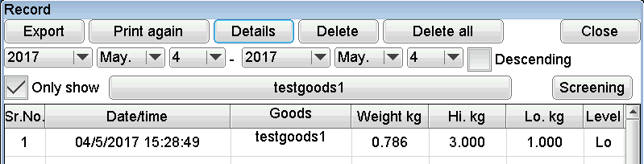

1. **Export file to U disk**

In the export option of goods select and check the record, user can choose export the file to U disk. The interface as follow:

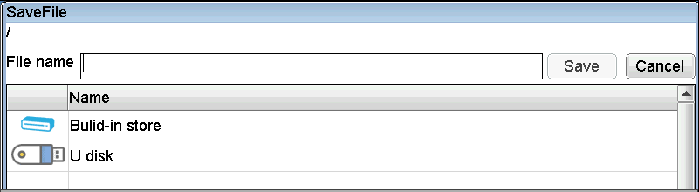

Press [U disk], choose the suitable folder, input the name of the file, then press [Save]. After “store succeed” shown, user can pull out the U disk.

1. **Parameter setting**

Click, then click  in the pop up window, user can enter the parameter setting. The window as follow:

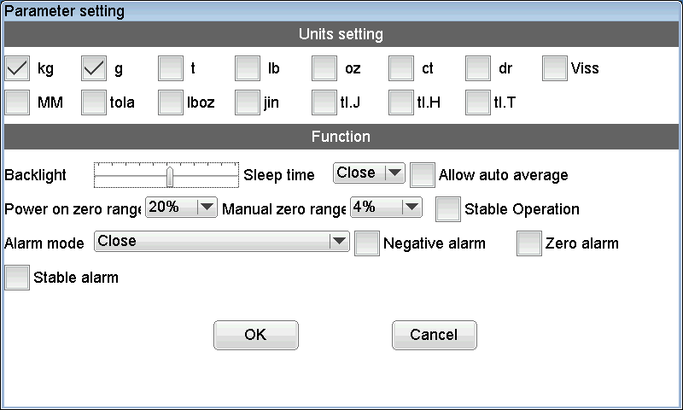

* 1. Unit setting

Tick the unit which need to use. Remove the tick for the unit which do not need to use. For an example, user need to use kg, tick it. User do not need to use g, remove the tick in front of it.

* 1. Function setting
     1. Backlight brightness

Sliding the slider to set the brightness of the back light. The brightness of backlight can timely changed.

* + 1. Sleep time

This function use to set the length of duration to control the backlight turns dark. For an example, this parameter set to 12,it means the backlight turn to dark after 12s. But need the indicator without operate and the weight value do not change. If the indicator operated or the weight value changed, the backlight will recover.

* + 1. Range of power on zero

It means the allowed difference of power on zero and calibration value. The default difference is 20%.

* + 1. Range of manual zero

It means the allowed difference of manual zero and power on zero. In this range, manual zero is effective. The default difference is 4%.

* + 1. Operate after stable

It means if zero and tare operate effective after scale stabled.

* + 1. Alarm mode

User can use this function to choose the alarm mode, also can close alarm function.

* + 1. Alarm in negative or zero weight value

Choose negative alarm, the alarm function effective when the weight is negative value.

Choose zero alarm, the alarm function effective when the weight is zero.

* + 1. Alarm after stable

Choose this function, the alarm function effective after scale stabled.

1. **Communication**
   1. setting

Click, then click  in the pop-up window, user can enter communication setting. The window as follow:

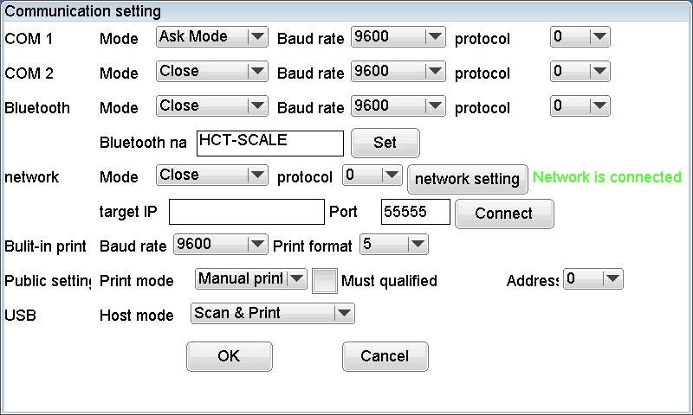

* + 1. Serial port COM1, serial port COM2, blue tooth
       1. Mode

Include sending mode, stable sending mode, answer mode, button sending mode, print mode and close this port.

Print mode setting, please refer to 21.1.3 common setting.

* + - 1. Baud rate

The highest baud rate setting is 115200, default setting is 9600.

* + - 1. Data protocol

This is communication format. When mode set to print mode, this parameter is for print format.

* + - 1. Name of blue tooth

Input the blue tooth name of equipment. The name must set to English letters and number, total 12 characters. After input, click [Set].

* + 1. network
       1. Mode

Include sending mode, stable sending mode, answer mode, button sending mode, mode print mode and close this port.

Print mode setting, please refer to 21.1.3 common setting.

* + - 1. Data protocol

This is communication format. When mode set to print mode, this parameter is for print format.

* + - 1. Target IP, port

Here use to input the server IP and port, it must be the TCP server. After input, click [Connect].

* + - 1. Network setting

Press [Network] to set the network.

* + - * 1. Wi-Fi version

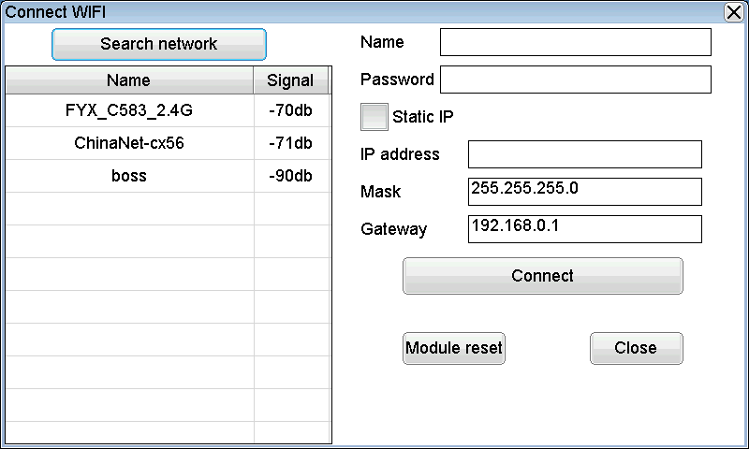Click  to search the Wi-Fi signal. All Wi-Fi name will come out in under window, choose and click the right Wi-Fi, input its password in right side sheet, click [connect].

* + - * 1. Wire version

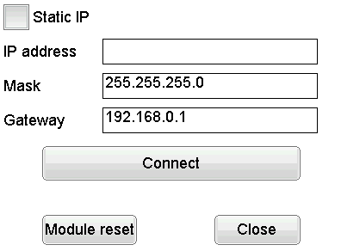

Click [connect] to use this function directly. Or choose static IP and input the IP address, mask, gateway, and then click connect key to connect. If user do not know these parameter, please contact the webmaster.

If user suspect the module crashed, please click [module reset] to reset.

* + 1. Common setting
       1. Print mode
          1. Manual print

Click [print] key to print out content once.

* + - * 1. Auto print

Put on the weights, after the weight value stabled, the indicator will print out content once.

* + - * 1. Qualified print

Put on the weights, after the weight value stabled, if the weight value is not in the no-alarm range, the indicator will print out content once.

* + - 1. In qualified range print

Choose this function, the indicator will just print in manual mode when weight value in qualified range.

* + 1. USB

When insert USB, scanner gun or keypad, user can define these equipment’s function.

* + - * 1. Analog keypad

Input letter and number will be shown in the input box.

* + - * 1. Scan goods

Input letter and number will not be shown in the input box. When software checked out the carriage return, the indicator will judge if there has goods serial number in the input content. If it has, the indicator will call out the goods and print out the corresponding content.

* + - * 1. Scan and print

Input letter and number will not be shown in the input box. When software checked out the carriage return, the indicator will print out the corresponding content.

* 1. Wire connection

Indicator with female connector (factory default)

|  |  |  |  |
| --- | --- | --- | --- |
| Connect to Indicator (male connector) | | Connect to PC port(female connector) | |
| Pin | Define | Pin | Define |
| 2 | TXD | 2 | RXD |
| 3 | RXD | 3 | TXD |
| 5 | GND | 5 | GND |

Indicator with male connector

|  |  |  |  |
| --- | --- | --- | --- |
| Connect to Indicator (female connector) | | Connect to PC port(female connector) | |
| Pin | Define | Pin | Define |
| 2 | RXD | 3 | TXD |
| 3 | TXD | 2 | RXD |
| 5 | GND | 5 | GND |

* 1. Default data protocol

|  |  |  |  |  |  |  |  |  |  |  |  |  |  |  |  |  |  |  |
| --- | --- | --- | --- | --- | --- | --- | --- | --- | --- | --- | --- | --- | --- | --- | --- | --- | --- | --- |
| S | T | , | N | T | , |  | 1 | 2 | 3 | 4 | . | 5 | 6 |  | k | g | CR | LF |
| Header1 | | | Header2 | | | 8 bits of weight value data | | | | | | | | Unit | | | 0D | 0A |

|  |  |  |  |
| --- | --- | --- | --- |
| Header1 | | Header2 | |
| ST, | Stable | NT, | Net weight |
| US, | Unstable | GS, | Gross weight |
| OV, | Over load | TR, | Tare weight |

Weight value data is ASCII character, may have follow characters:

“ 0” ~ “9” number “ ” blank “ . ”Decimal point “ - ” negative sign

1. **Time setting**

Click, then click  in the pop-up window to enter the time setting. The window as follow:

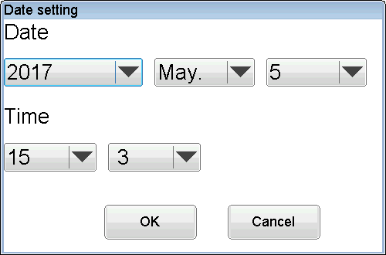

After choose the right date and time, click [ok].

Note: After click [ok], the second clock will be set to 0.

1. **User management(Option)**
   1. Edit user information

Click, then click  in the pop-up window to enter the edit user information function. The window as follow:

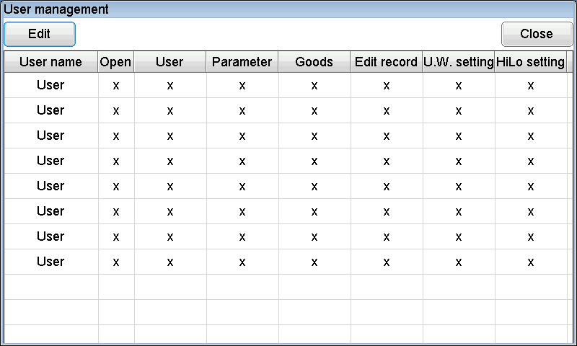

Choose the responding user, click [edit] to edit user information.

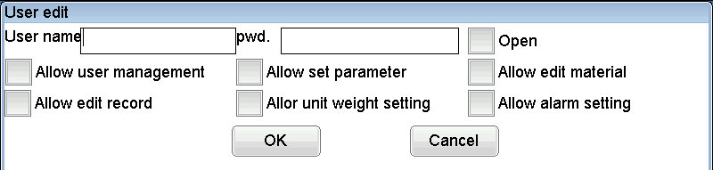

To start using one user, user must set the user name and password, and tick [open].

Other permissions depend on the requirement of user.

Note: The default user name is Admin, all the permissions of it is opened. Please change its password in time.

* 1. Password modify

Click, then click 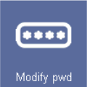 in the pop-up window to enter the password modify function. The window as follow:

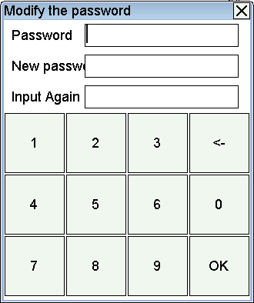

Input the old password, the input the new password twice, click [ok] to complete the modify.

* 1. User login

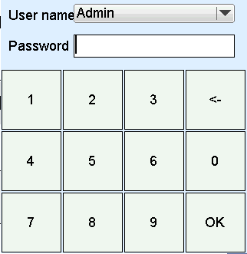

Choose user name and input the right password, then click [ok] to login. After login succeed, the user name will be shown on the top left corner.

1. **Units conversion**

1 kg = 1000g

1 lb = 453.59237g

1 oz = 28.349523125g

1. **Error information**

|  |  |  |
| --- | --- | --- |
| Display | Error | solution |
| ADO--- | AD value over flow | Take off the weights or send to repair |
| ADL--- | AD value over flow | Take off the weights or send to repair |
| OVR--- | Over load | Check if the weight of weighs is +9e more that the Max. Cap. |
| Batter sign red | Low power | Charging |
| Low battery, please charging | Battery ‘ voltage is very low | Stop using and charging |